Possible works for Jaffrey Center Show Oct. 18 – Nov. 15, 2019

Essential Childscapes and Kanji Landscapes by Susan M. Wadsworth

Hang show: Oct. 16-17, 2019; room for roughly one dozen pieces per room

Prices reflect the increase of April 1 to 50% for Tamar.

Included here are mostly works that are framed, chronologically arranged
(a few works in later series are included but are not yet framed)

The other images in the series are usually seen in my website: http://susanwadsworthworksonpaper.com/ You can also see larger images in better resolution. If you like, you can make a visit to my studio to see the works in person.

1) Aerial and other landscapes from the 1990s, often inspired by flying with my husband in a small plane

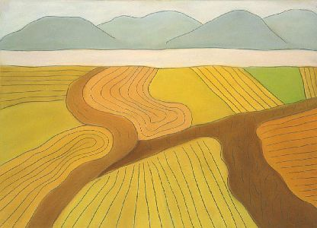 Flight to Asheville, NC, January 1990 January 1990 pastel and pencil on Arches paper 26” x 36” Price: $2900

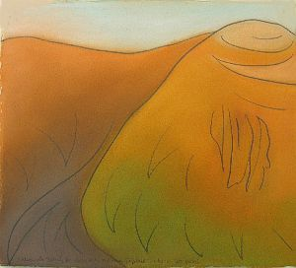 Study for Greylock Triptych, left panel Nov. 2, 1990 pastel and pencil on Arches paper 12 x 13 1/2” Price: $1000

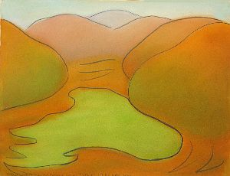 Study for Greylock Triptych, central panel Nov. 2, 1990 pastel and pencil on Arches paper 12 x 13 1/2” Price: $1000

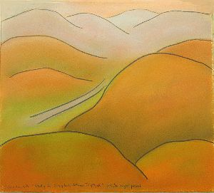 Study for Greylock Triptych, right panel Nov. 2, 1990 pastel and pencil on Arches paper 12 x 13 1/2” Price: $1000 (The larger oil paintings are more awkwardly painted than these little studies).

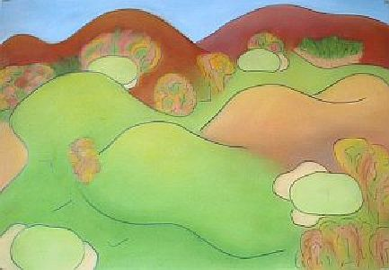 Ekwanok in October: #7, 8, 9, 11, 12” 1991 pastel and pencil on Arches paper 15” x 31” cost: $20 Price: $800.00

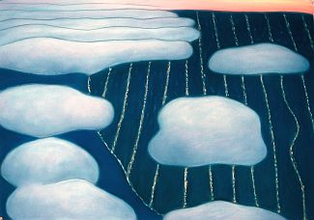 Approaching O’Hare: Clouds Clearing over Chicago, Dusk 1992 pastel and pencil on Arches paper 25 5/8” x 36 3/8” $3000.00 Shown at the Windham Art Gallery Abstract Show November 2004.

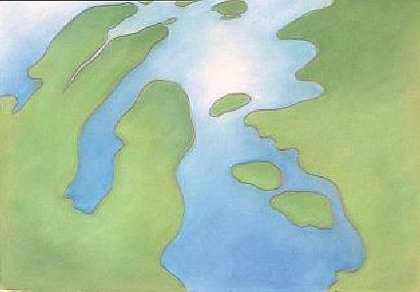 Winnepesaukee #5: Center Harbor 1994 pastel and pencil on Arches paper 21” x 30” $2500.00 framed.

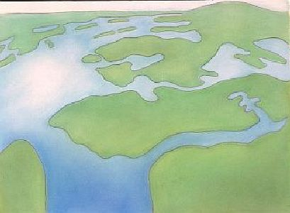 Winnepesaukee #6: View north from Wolfeboro 1994 pastel and pencil on Arches paper 22” x 30 1/2” Price: $2500.00 framed.

There are four more works in this Wininepesaukee series, not yet framed.

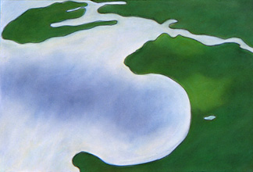 Gwynn’s Island III: Center View, Closing in on the Island 1995 pastel and pencil on Arches paper 21” x 30” Price: $2500.00 framed.

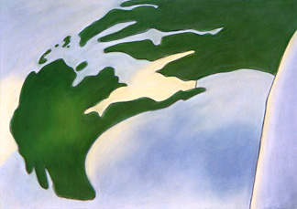 Gwynn’s Island V: Leftmost, Eastmost View, Light over the Island 1995 pastel and pencil on Arches paper 21” x 30” Price: $2500.00 framed. Shown at the Windham Art Gallery

There are three more works in this Gwynn’s series, not yet framed.

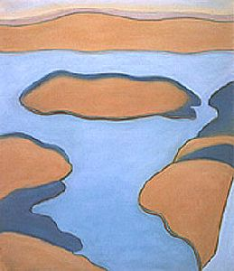 October over Quabbin II August 1996 pastel and pencil on Arches paper c. 21 ¼” x 15” $2000 framed.

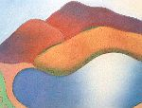 Monadnock Fall I: Dublin View 1999 pastel and pencil on Arches paper 26 1/4” x 38” $3000.00 framed. (Fix the broken glass on this)

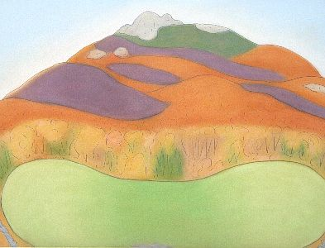 Monadnock Fall II: Farm View, route 124 1999 pastel and pencil on Arches paper 26 1/4” x 38” $2000.00. Port I. Not yet framed.

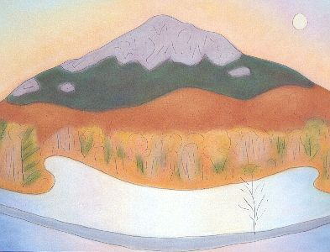 Monadnock Fall III: Perkins Pond 1999 pastel and pencil on Arches paper 26 1/4” x 38” $2000.00 if unframed; $3000 framed. Not sure if this is framed yet.

2) Childscapes, inspired by Lizzie’s birth in 1999 (aka Sarah); images of children from the mother’s point of view

Ninth Month 1999 pastel and pencil on Arches paper 25” x 20 ½” $2750 framed. Shown at Ex Umbris, Ad Lucem, Franklin Pierce College, Rindge, NH. September 2000 and at the Stoneleigh-Burnham School, Greenfield, MA January 2005.

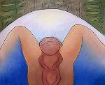 Spring Waterbirth (Sarah) 1999 pastel and pencil on Arches paper 21 1/2” x 24 1/4”: $2750. Shown at Ex Umbris, Ad Lucem, Franklin Pierce College,

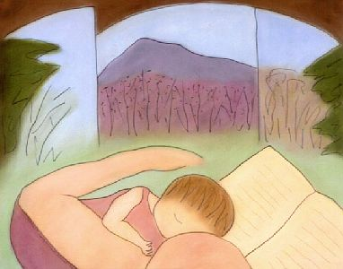 Spring Nursing, Mt. Monadnock 1999 pastel and pencil on Arches paper 21 1/4” x 24 7/8” $3000. Shown at Ex Umbris, Ad Lucem, Franklin Pierce College, Rindge, NH. September 2000, Art of Breastfeeding, Amy’s Bakery, Brattleboro, VT, 2004 and at the Stoneleigh-Burnham School, Greenfield, MA January 2005.

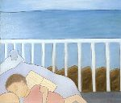 Morning Nursing, Cliff House, Ogunquit Maine 1999 pastel and pencil on Arches paper 26” x 30” $3000 Shown at the Windham Art Gallery, the Stoneleigh-Burnham School, Greenfield, MA. January 2005.
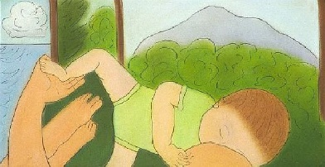 Reclining Nursing, Mt. Monadnock 1999 pastel and pencil on Arches paper 12 1/4” x 23 1/8” $1500. Shown at Mocha Alley, Childscapes, Sept. 16-Oct. 21, 2000 the Art of Breastfeeding, Amy’s Bakery, Brattleboro, VT, 2004, and at the Stoneleigh-Burnham School, Greenfield, MA January 2005.

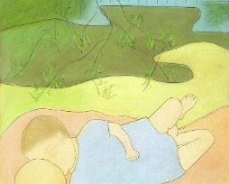 Vermont Nursing I: Battenkill Views 1999 pastel and pencil on Arches paper 21” x 25” $2000. Shown at Art of Breastfeeding, Amy’s Bakery, Brattleboro, VT, 2004, Mocha Alley, Childscapes, Sept. 16-Oct. 21, 2000 and at the Stoneleigh-Burnham School, Greenfield, MA January 2005.

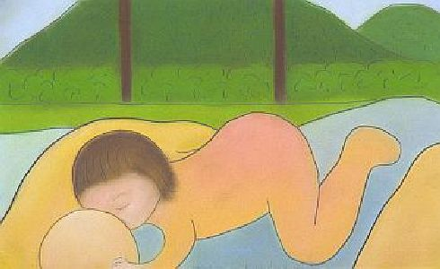 Yearling Nursing, Almost Weaned 2000 pastel and pencil on Arches paper 13 5/8 x 22 ½” $1500. Shown at Art of Breastfeeding, Amy’s Bakery, Brattleboro, VT, 2004, Mocha Alley, Childscapes, Sept. 16-Oct. 21, 2000 and at the Stoneleigh-Burnham School, Greenfield, MA January 2005.

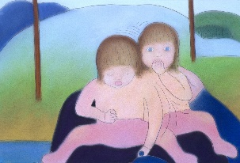 Sarah in Lap, Playing with Buttons 2000 pastel and pencil on Arches paper 18 3/8” x 27 Price: $2000

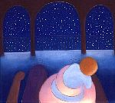 Rocking Baby, Midnight 1999 pastel and pencil on Arches paper 27 1/4” x 30” cost: $4000. Shown at the Windham Art Gallery, Mocha Alley, Childscapes, Sept. 16-Oct. 21, 2000 and at the Stoneleigh-Burnham School, Greenfield, MA. January 2005.

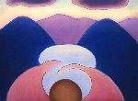 Jack’s Abstraction: Holding Baby Landscape 1999-2000 pastel and pencil on Arches paper 21” x 28” $3000. Mocha Alley, Childscapes, Sept. 16-Oct. 21, 2000. Also shown at the Windham Art Gallery and at the Stoneleigh-Burnham School, Greenfield, MA. January 2005.

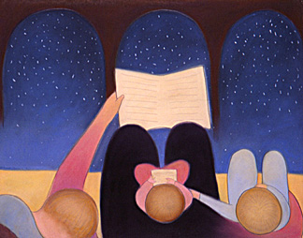 Bedtime I 2000 pastel and pencil on Arches paper 24 7/8” x 31 1/8” $3000 framed. Shown at Mocha Alley, Childscapes, Sept. 16-Oct. 21, 2000. Also shown at the Windham Art Gallery and at the Stoneleigh-Burnham School, Greenfield, MA January 2005.

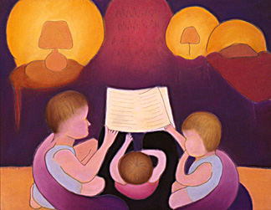 Bedtime II 2000 pastel and pencil on Arches paper 26” x 34” $3000 framed. Shown at Mocha Alley, Childscapes, Sept. 16-Oct. 21, 2000. Also shown at the Windham Art Gallery and at the Stoneleigh-Burnham School, Greenfield, MA January 2005.

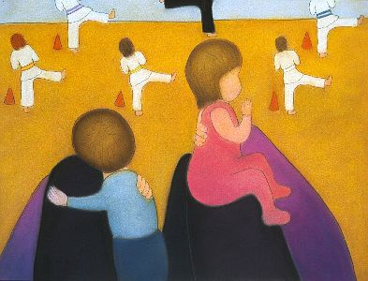 Watching Kosho Class 2000 pastel and pencil on Arches paper 24 1/4” x 31 $2000. Shown at the Windham Art Gallery, Mocha Alley, Childscapes, Sept. 16-Oct. 21, 2000 and at the Stoneleigh-Burnham School, Greenfield, MA January 2005.

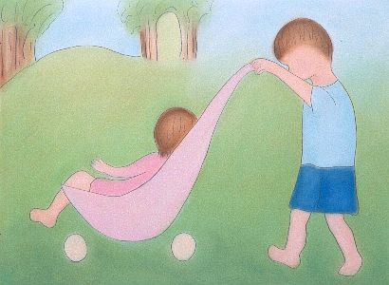Helping Mommy II: Brother Strolling Sister 2001 pastel and pencil on Arches paper 33 ½” x 25 ¼” $3000 framed.

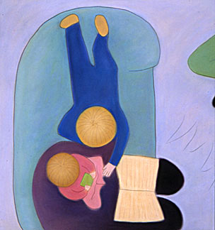 Sofa Cuddle 2000 pastel and pencil on Arches paper c. 35” x 30” $3500. Shown at the Windham Art Gallery and the Biennial Regional Juror’s Choice Competition, Thorne-Sagendorph Art Gallery, Keene State College, Keene, NH. Fall 2000.

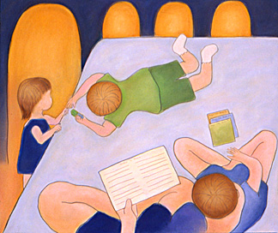 Reading Lesson I, J & S Playing 2000 pastel and pencil on Arches paper 26 ¼” x 31 3/8” $3000. Shown at the Windham Art Gallery, Mocha Alley, Childscapes, Sept. 16-Oct. 21, 2000 and at the Stoneleigh-Burnham School, Greenfield, MA January 2005.

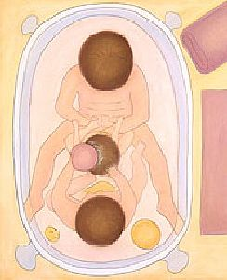 Rub-a-dub-dub, Siblings in a Tub 2000 pastel and pencil on Arches paper 31 1/8” x 26 1/8” $3000. Shown at the Windham Art Gallery, Mocha Alley, Childscapes, Sept. 16-Oct. 21, 2000 and at the Stoneleigh-Burnham School, Greenfield, MA January 2005.

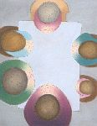 After September 11: Freedom of Worship, Freedom from Want (Timberkill Grace) 2001 pastel and pencil on Arches paper 25 ½ x 31 1/2” $650.00 unframed (may be framed….for $3000 if framed)

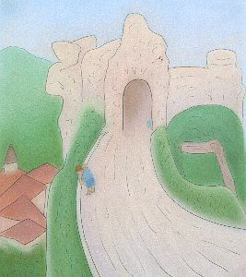 Les Baux I: Provence 2002 pastel and pencil on Arches paper 29 1/16” x 25 ½” Each work is $3000, Triptych is $8000. Shown at the FSC Faculty Show fall 2002 and at the Windham Art Gallery.

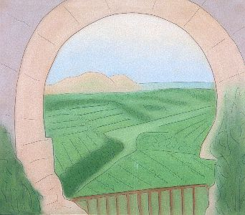 Les Baux II: View from the Ruins of the Chateau 2002 pastel and pencil on Arches paper 29 1/2” x 34 5/8” Each work is $3000, Triptych is $8000. Shown at the FSC Faculty Show fall 2002 and at the Windham Art Gallery. Shown by itself at the Windham Art Gallery June 2008 as part of the members back show.

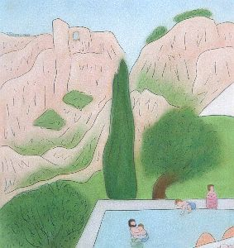 Les Baux III: View from Hotel (Mas D’Aigret) 2002 pastel and pencil on Arches paper 29 1/2” x 27 3/8” Each work is $3000, Triptych is $8000. Shown at the FSC Faculty Show fall 2002 and at the Windham Art Gallery.

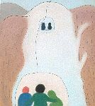 Skiing Mt. Sunapee II: Sunbrook Chair 2003 pastel and pencil on Arches paper 34 1/2” x 30” $3000.00 framed. Shown at the Windham Art Gallery’s Shared Inspiration, May 2005.

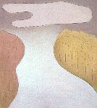 Skiing Mt. Sunapee III: Last Run 2003 pastel and pencil on Arches paper 34 1/4” x 30” $3000.00 framed. Shown at the Windham Art Gallery’s Shared Inspiration, May 2005.

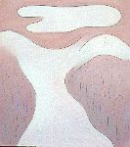 Skiing Mt. Sunapee IV: Last Light 2003 pastel and pencil on Arches paper 34 1/4” x 30” $3000.00 framed. Shown at the Windham Art Gallery’s Shared Inspiration, May 2005.

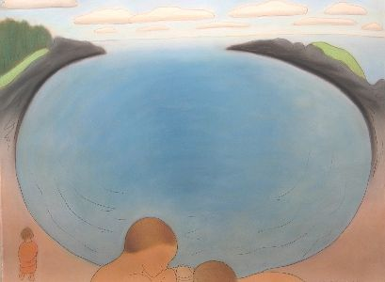 Small Point, Maine June 2004 2004 pastel and pencil on Arches paper 32” x 42 ½” $4000. Shown at the Windham Art Gallery’s Small Point, Maine. September 2004, Stoneleigh-Burnham School, Greenfield, MA. January 2005, and at the Biennial Regional Juror’s Choice Competition, Thorne-Sagendorph Art Gallery, Keene State College, Keene, NH. December 2006 – January 2007.

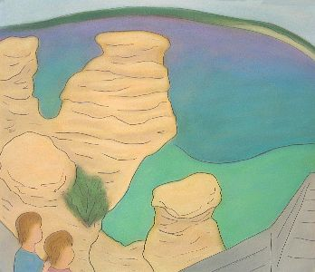 Pictured Rocks, Michigan 2005, pastel and pencil on Arches paper c. 33” x 36” $3000.00 framed. Shown at the Windham Art Gallery and at the Biennial Regional Juror’s Choice Competition, Thorne-Sagendorph Art Gallery, Keene State College, Keene, NH. December 2006 – January 2007. Shown in the “Well Being” show of the Central Mass WCA at the Monadnock Community Hospital’s Healing Arts Gallery June – Sept. 2017.

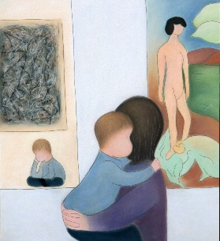 Matisse/Picasso, MOMA 3/28/03: “Your son is a work of art.” 2003 pastel and pencil on Arches paper 36 ¼” x 32 ¼” $5000. Shown at the Windham Art Gallery and at the Stoneleigh-Burnham School, Greenfield, MA January 2005;
Inner Resonance: WCA at the community gallery of the Fitchburg Art Museum, April 2015.

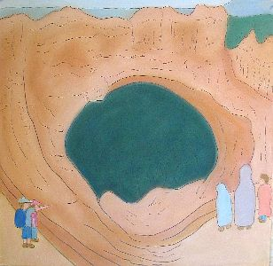Bryce Canyon I: Natural Bridge, “You have to get out of the car to see this” 2005 pastel and pencil on Arches paper c. 29” x 27” $3000.00 framed. Shown at the Windham Art Gallery Inside/Outside, November 2005, and at the FSC Faculty Show Fall 2005. Shown in the “Well Being” show of the Central Mass WCA at the Monadnock Community Hospital’s Healing Arts Gallery June – Sept. 2017.

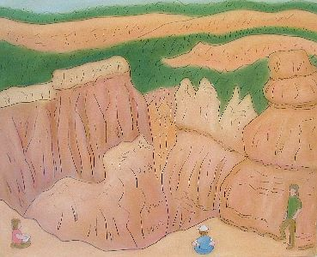 Bryce Canyon II: Hoodoo View 2005 pastel and pencil on Arches paper 29 ½” x 35” $3000.00 framed. Shown at the Windham Art Gallery Inside/Outside, November 2005, and at the FSC Faculty Show Fall 2005. Shown in the “Well Being” show of the Central Mass WCA at the Monadnock Community Hospital’s Healing Arts Gallery June – Sept. 2017.

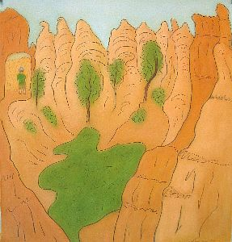Bryce Canyon III: Queen’s Garden 2005 pastel and pencil on Arches paper 29 ½’ x 27 ½” $3000.00 framed. Shown at the Windham Art Gallery Inside/Outside, November 2005, and at the FSC Faculty Show Fall 2005. Shown in the “Well Being” show of the Central Mass WCA at the Monadnock Community Hospital’s Healing Arts Gallery June – Sept. 2017.
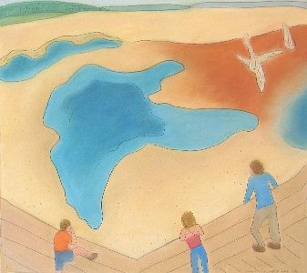 Yellowstone I: Emerald Pool 2005 pastel and pencil on Arches paper 27” x 30 ½” $2750.00 framed. Shown at WAG.

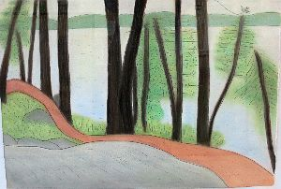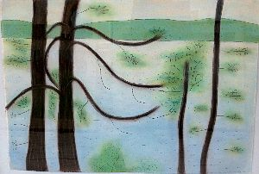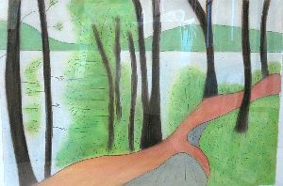
Keewaydin Triptych 2005 pastel and pencil on Arches paper each panel is approximately 24’ x 31” $1000 Each work is $2000, Triptych is $5000. Shown at the Windham Art Gallery Sense of Place, October 2004.

Small Point, Maine June 2004 2004 pastel and pencil on Arches paper 32” x 42 ½” $6000. Shown at the Windham Art Gallery’s Small Point, Maine. September 2004, Stoneleigh-Burnham School, Greenfield, MA. January 2005, and at the Biennial Regional Juror’s Choice Competition, Thorne-Sagendorph Art Gallery, Keene State College, Keene, NH. December 2006 – January 2007.

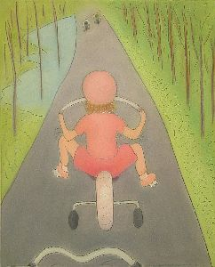 Sarah Six, Biking, Gardner Trails 2006 pastel and pencil on Arches paper 30 x 25” $3000 framed. Shown at the Windham Art Gallery’s Figurative, May 2006. “Well Being” at the Healing Arts Gallery, Monadnock Community Hospital, a WCA/MA exhibition,June-August, 2017.

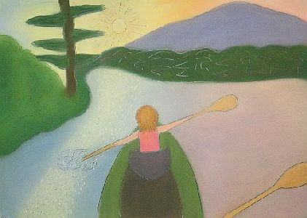 Sarah Six, Kayaking, Pool Pond, NH, Sunset Magic 2006 pastel and pencil on Arches paper 23 1/2” x 33 ½” $3000 framed. Shown at the Windham Art Gallery’s Figurative, May 2006. “Well Being” at the Healing Arts Gallery, Monadnock Community Hospital, a WCA/MA exhibition, June-August, 2017.

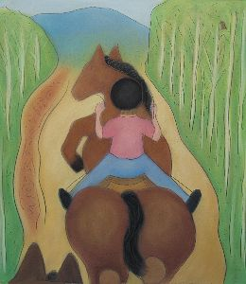 Sarah Six, Riding Misty, Latigo Ranch, Colorado 2006 pastel and pencil on Arches paper c. 31 x 27” $3000 framed. Shown at the Windham Art Gallery’s Figurative, May 2006. “Well Being” at the Healing Arts Gallery, Monadnock Community Hospital, a WCA/MA exhibition,June-August, 2017.

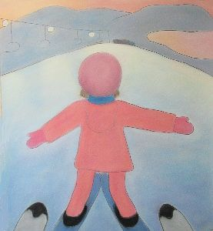 Sarah Six, Skiing, Crotched Mountain 2006 pastel and pencil on Arches paper 30 x 27 ½” Price: $3000. Shown at the Windham Art Gallery’s Figurative, May 2006. It was shown at the Fall Show, “Chromatic” at the SVAC in September 2016. Shown at the Windham Art Gallery’s Figurative, May 2006. “Well Being” at the Healing Arts Gallery, Monadnock Community Hospital, a WCA/MA exhibition, June-August, 2017.

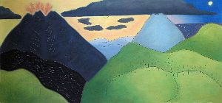 Picaya Hike, New Years Day, Guatemala 2007 pastel and pencil on Arches paper 29” x 60 ½” $7000.00 framed. Shown at WAG in early 2007 and was on loan for some time to the Faculty Center at FSU before it was renovated. It was also shown at the CMWCA “In the Beginning” at the Townsend
Library Meeting Hall Gallery.

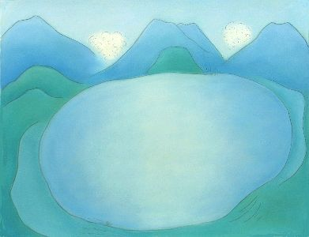 Lake Atitlan 2007 pastel and pencil on Arches paper c. 32” x 42” $4500.00 framed. Shown at Windham Art Gallery Works on Paper, April 2007 and at the Faculty Center at FSC.

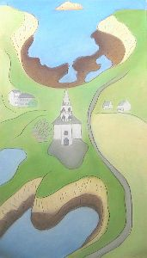 Ile d’Ouessant, Brittany, France 2007 pastel and pencil on Arches paper 42 ½” x 24 1/4” $3500.00 Shown at the Windham Art Gallery solo show Brittany Summers, New England Winters April 2008 and at the Southern Vermont Artists Solo Show February 2010.

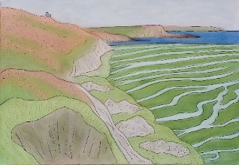 Brittany Seaweed Patterns I 2007 pastel and pencil on Arches paper 24” x 35” $3000 Shown at the Windham Art Gallery solo show Brittany Summers, New England Winters April 2008 and at the Southern Vermont Artists Solo Show February 2010.

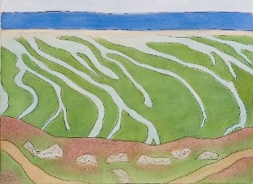Brittany Seaweed Patterns II 2007 pastel and pencil on Arches paper 26” x 35 1/2” $3000 Shown at the Windham Art Gallery solo show Brittany Summers, New England Winters April 2008 and at the Southern Vermont Artists Solo Show February 2010.

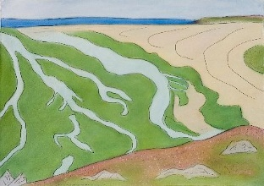Brittany Seaweed Patterns III 2007 pastel and pencil on Arches paper 25” x 35 1/2” $3000 Shown at the Windham Art Gallery solo show Brittany Summers, New England Winters April 2008 and at the Southern Vermont Artists Solo Show February 2010.

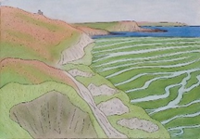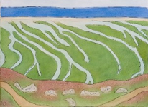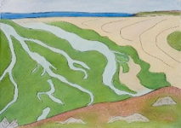

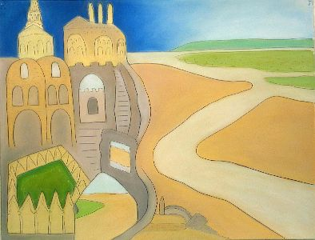 Mont St Michel Day Night 2007 27 ¾” x 36 ¼” pastel and pencil on Arches paper pastel and pencil on Arches paper $3000. Shown at the Windham Art Gallery solo show Brittany Summers, New England Winters April 2008 and at the Southern Vermont Artists Solo Show February 2010.

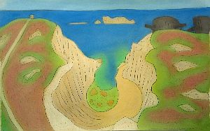 Camaret sur Mer I Pointe Pen Hir German pillboxes 2007 26 5/8” x 42 ½” pastel and pencil on Arches paper $4000 Shown at the Windham Art Gallery solo show Brittany Summers, New England Winters April 2008 and at the Southern Vermont Artists Solo Show February 2010.

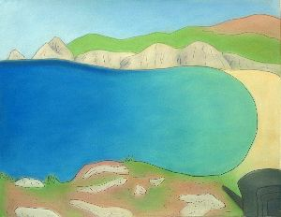 Camaret sur Mer II Pen Hom Beach 2007 pastel and pencil on Arches paper 26 1/8” x 34 3/8” $3000 Shown at the Windham Art Gallery solo show Brittany Summers, New England Winters April 2008 and at the Southern Vermont Artists Solo Show February 2010.

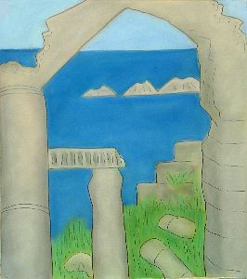 Camaret sur Mer III Ruined Manor of Saint Pol Poux 2007 27 5/8” x 24 ¾” pastel and pencil on Arches paper $2750. Shown at the Windham Art Gallery solo show Brittany Summers, New England Winters April 2008 and at the Southern Vermont Artists Solo Show February 2010.

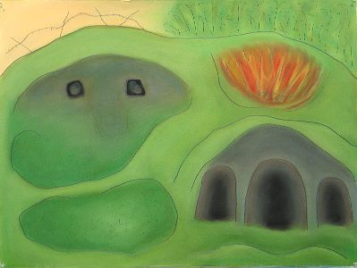 Verdun I: Fort Souville 2007 pastel and pencil on Arches paper 24½” x 33” $3000. Shown at the Windham Art Gallery show Horror 2007.

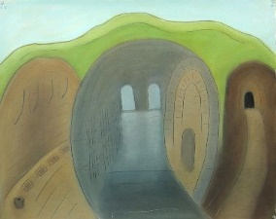 Verdun II: Fort Douaumont, Latrine and Dormitory 2007 pastel and pencil on Arches paper 26 ½” x 32 1/2” $3000 Shown at the Windham Art Gallery show Horror 2007.

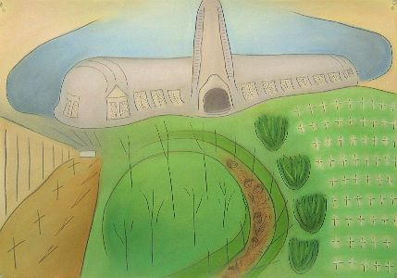Verdun III: Ossuaire, Bayonet Trench 2007 pastel and pencil on Arches paper 25” x 35 1/2” $3000. Shown at the Windham Art Gallery show Horror 2007.

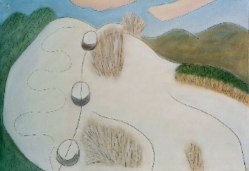 Skiing I: Frosty Sunapee 2007-2008 pastel and pencil on Arches paper 23 1/2” x 34 1/2” $3000.00

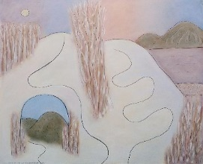 Skiing II: Stunning Stratton, 12/21/07 12/24/07 pastel and pencil on Arches paper 26 1/2” x 33” $3000.

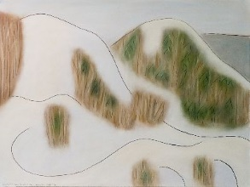 Skiing III: Muted Magic 2007-2008 pastel and pencil on Arches paper 23 1/2” x 31 1/2” $3000.00

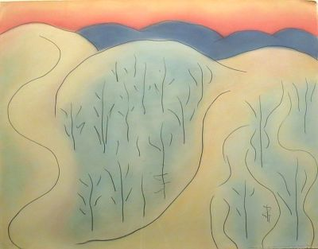Crotched Mountain, Comet Drop 2009 pastel and pencil on Arches paper, 24” x 32” $3000. Shown at the FSU Faculty show 2011 and at a Thorne Sagendorf regional show c. 2012 or so. Shown at SVAC solo show in Feb. 2016. Shown at the Sitka Gallery, Fitchburg, “Earth Day” show April-May 2017.

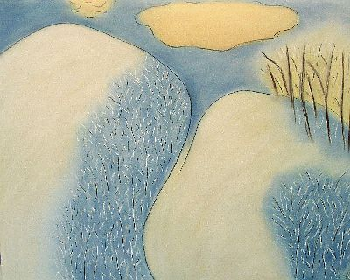 Icy Crotched 2011 pastel and pencil on Arches paper c. 26 x 32” $3000. Shown at the FSU Faculty show 2011 and elsewhere.

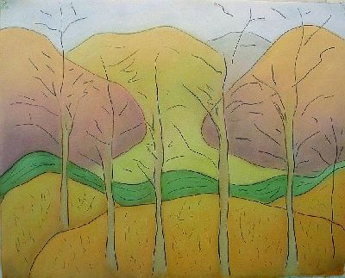 Ridge Spring Panorama III: VT NY State Line 2011 pastel and pencil on Arches paper c. 26 x 32” price: $4000. Shown at ASA Columbus Day Sale, Coila, NY and at the Valley Artisans solo show May 2014. Shown at the SVAC Members’ Show summer 2017. This is one of a series of four, the other three of which have not been framed as of yet.

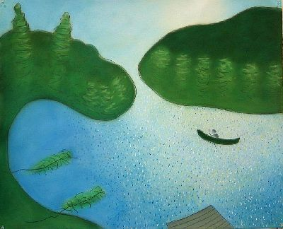 Morning Light, Keewaydin, Algonquin to Song, 2011 pastel and pencil on Arches paper 25 x 32” $3000. Shown at the Sitka Gallery, Fitchburg, “Earth Day” show April-May 2017. Shown in the “Well Being” show of the Central Mass WCA at the Monadnock Community Hospital’s Healing Arts Gallery June – Sept. 2017.

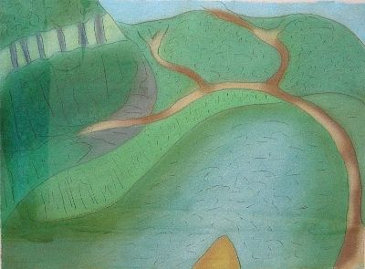 Canoeing and Kayaking the Battenkill, Two Days before Irene September 2011 pastel and pencil on handmade paper 22 x 29” $3000. Exhibited at FAM Annual Exhibition Summer 2012 and the 57th Fall Open at the SVAC. (Photo taken with glass; please ignore reflection on the left.) Shown in the window of the Valley Artisans solo show May 2014.

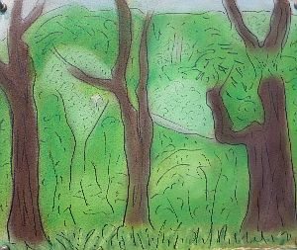 Ridge view to 313 2013 pastel and pencil on Arches paper c. 10 ¼ ” x 13 ½” $1000. A “walk and draw” work. Shown at the Valley Artisans solo show May 2014. Shown at SVAC solo show in Feb. 2016; SVAC Winter Members Show Nov.-Dec. 2017.

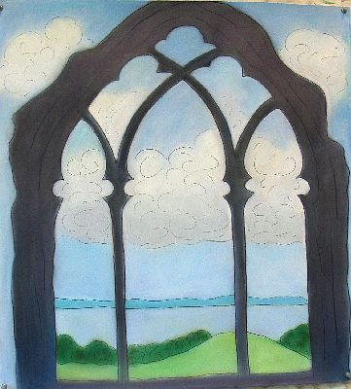 British Ruins I: Oystermouth Castle Chapel, The Mumbles, Wales August 2012 pastel and pencil on Arches paper 28.5 x 26” $3000. Shown at the Jaffrey preview show for FFAST Fall 2012 I think. Also at the Valley Artisans solo show May 2014. Shown at SVAC solo show in Feb. 2016. . It was also shown at the CMWCA “In the Beginning” at the Townsend Library Meeting Hall Gallery.

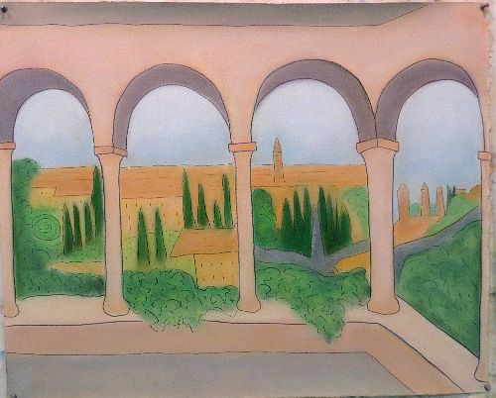 Giusti Gardens, Verona View August 2013 pastel and pencil on Arches paper 32” x 26” $3000. Framed Nov. 2013 for Faculty Show and Valley Artisans show. Shown at SVAC solo show in Feb. 2016.

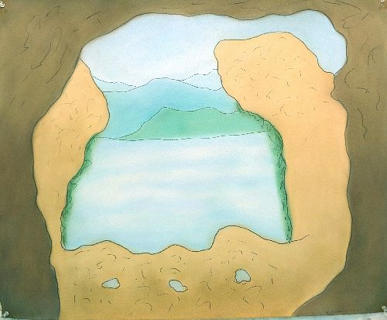 Roman Ruins VII Villa Catullus, Sirmione Italy, July 2013 pastel and pencil on Arches paper 26 x 32” $3000. Framed Nov. 2013 for Faculty Show and Valley Artisans show. Shown at SVAC solo show in Feb. 2016. It was also shown at the CMWCA “In the Beginning” at the Townsend Library Meeting Hall Gallery.

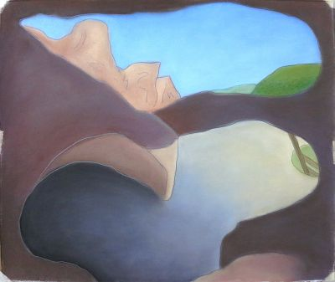 Bandelier Caves: Inside and Out, Sept. 7, 2014 pastel and pencil on paper 26” x 31” $3000. Shown at WCA Inner Resonance show at the Fitchburg Art Museum and at SVAC Members show, Southern Vermont Artists, Manchester, VT.

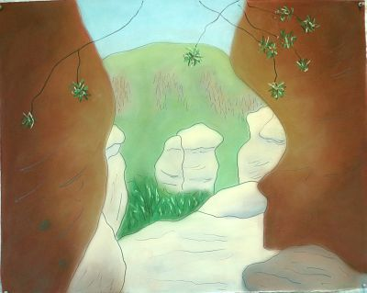 Chiricahua Rocks, Massai Point Nov. 2014 pastel and pencil on paper, 26” x 31,” $3000. Exhibited at Biennial Regional Juror’s Choice Competition, Thorne-Sagendorph Art Gallery, Keene State College, Keene, NH. January to February 2015. Also shown at WCA Inner Resonance show at the Fitchburg Art Museum and at SVAC Members show, Southern Vermont Artists, Manchester, VT. And at the Munroe Center for the Arts Galleries, Lexington, MA for the Jump Start Central Massachusetts Women’s Caucus for Art Jan-Feb. 2016.

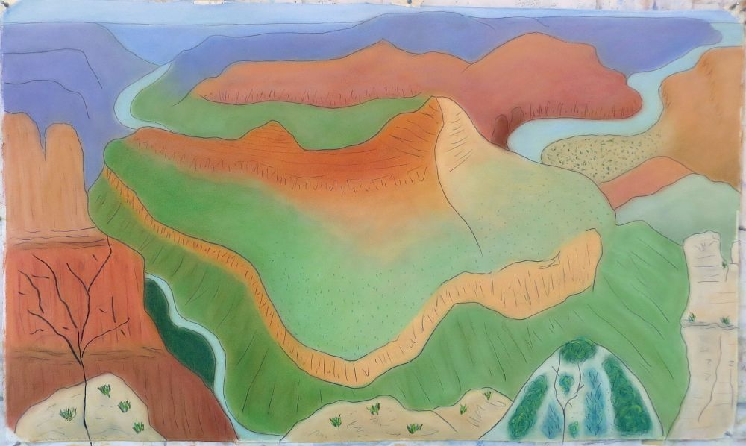 Grand Canyon II, from Desert View Nov. 2014, pastel and pencil on paper, 31” x 52” $7000. Shown at the FSU Faculty Show Dec. 2015 and the Southern Vermont Artists solo show Feb. 2016. Shown at the Fitchburg Art Museum 81st Regional exhibition summer 2016.

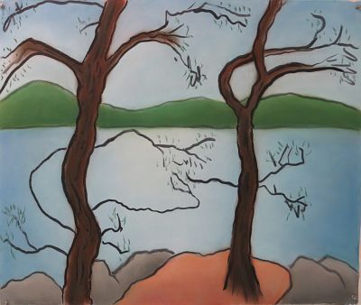 Temagami View from Paul’s Island September 2015 pastel and ink on Arches paper, $3000. Shown at the Munroe Center for the Arts Galleries, Lexington, MA for the Jump Start Central Massachusetts Women’s Caucus for Art Jan-Feb. 2016 and the Southern Vermont Artists Spring Members show April-May 2016.

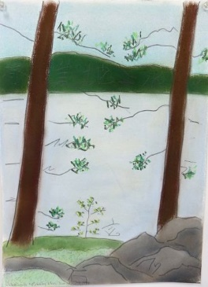 Ojibway Water Tower View 8/13/17 pastel and pencil on Arches paper 14” x 10.5” $1000 Shown at WCA “Something Wild” exhibition at the The Arthur Whitty Gallery at Wild Salamander Creative Arts Center, Hollis, NH Sept. 2017.

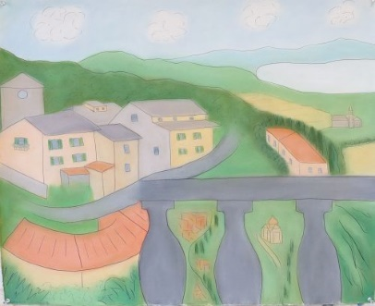 Cortona Views September 2016 pastel and pencil on Arches paper 26” x 32” $3000 Shown at the SVAC Members’ Show summer 2017.

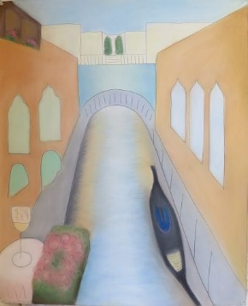 Venice Memories, for Lizzie September 2016 pastel and pencil on Arches paper 32” x 26”, $3000 Shown at the SVAC Members’ Show summer 2017.

Unframed works from summer 2017 and later

I’m interested in framing some new works for the Jaffrey show, so if you want to write about these, do so.

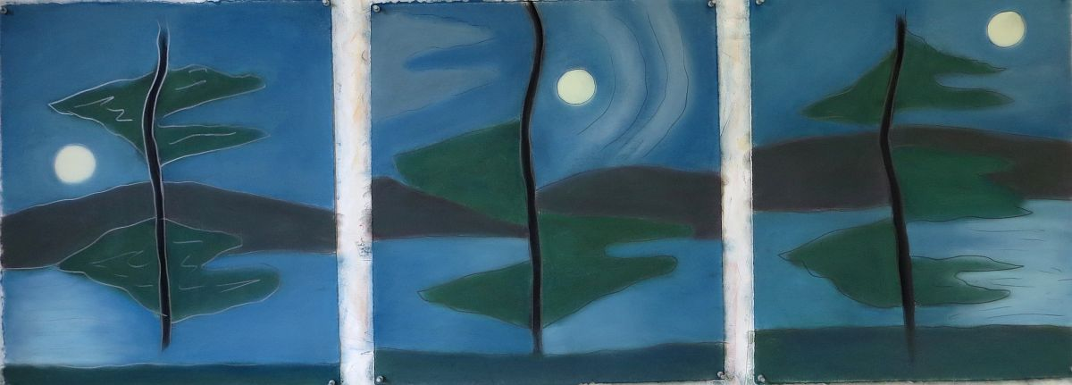Squam Lake Moonrise Triptych 2017 pastel and pencil on Stonehenge paper each work: 19” x 16.5” $600 each unframed.

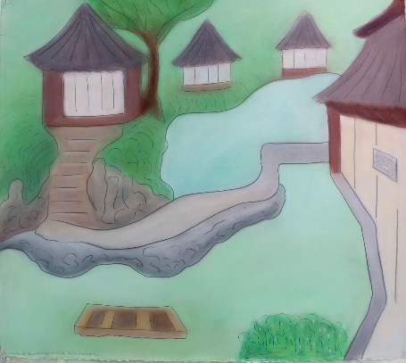 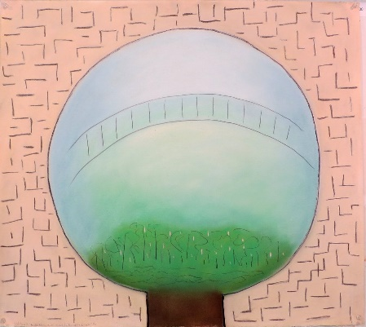 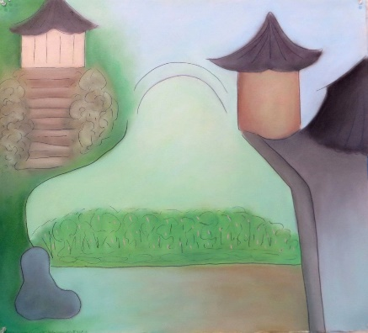 Humble Administrator’s Garden, Suzhou, China Triptych July 2017 each work: 26” x 29” pastel and pencil on paper $2000 each unframed; $5000 for triptych.

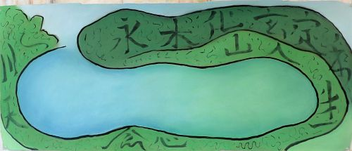 Kanji Landscape #1 July 2017 pastel pencil ink on Stonehenge paper 21.5” x 52” $2500 unframed.

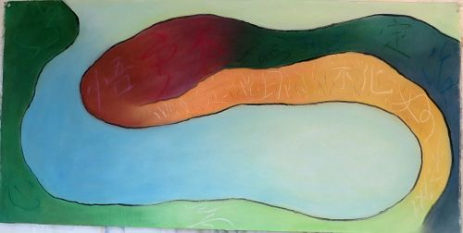Large Kanji Landscape #2 July to August 2017 pastel pencil ink on Arches paper 20” x 42” $2500 unframed.

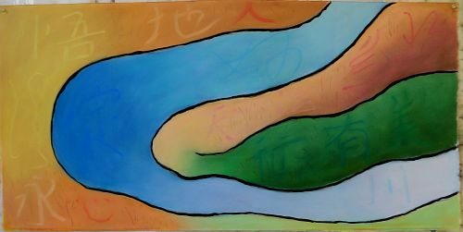 Large Kanji Landscape #3 2017 pastel and pencil on Arches paper : $2500 unframed.

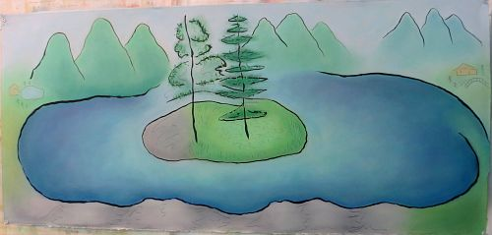 Chinese Landscape with Island 2017 pastel and pencil on paper 21” x 46” $2500 unframed.

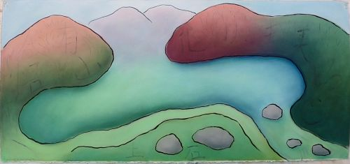 Fall Kanji Landscape, 2017, pastel and pencil on Arches paper 21” x 46” $4000 framed.

